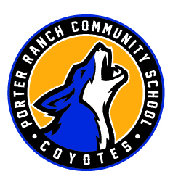
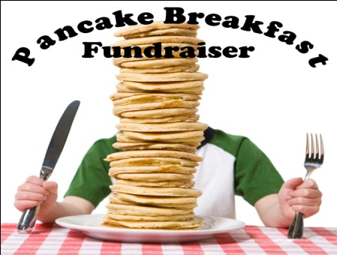

at

Community Event!! Come one, come all!!
Let’s all get together PRCS!!
Saturday, April 16
8:00 am – 10:00 am
$10 per person - Breakfast includes:
Pancakes, Scrambled Eggs, Sausage, and Country Potatoes.
at
9255 Winnetka Ave., Chatsworth

Buy your tickets at our PRCS Student Store
or in the morning in front of the Main Office!
Make all checks payable to PRCS Student Body
Thank you for your Support!
------------------------------------------------------------------------------------------------------

Student’s Name:______________________
Parent’s Name:_______________________ Contact Number:__________________
# of Tickets: _______ Room # or 1st Period Room #: ______
Total Amount Enclosed: ___________

